**Project Design Phase-II**

**Data Flow Diagram &User Stories**

|  |  |
| --- | --- |
| Date | 03October 2022 |
| Team ID | PNT2022TMID40555 |
| Project Name | Emerging Methods for Early Detection of Forest Fires |
| Maximum Marks | 4 Marks |

**Data Flow Diagrams:**

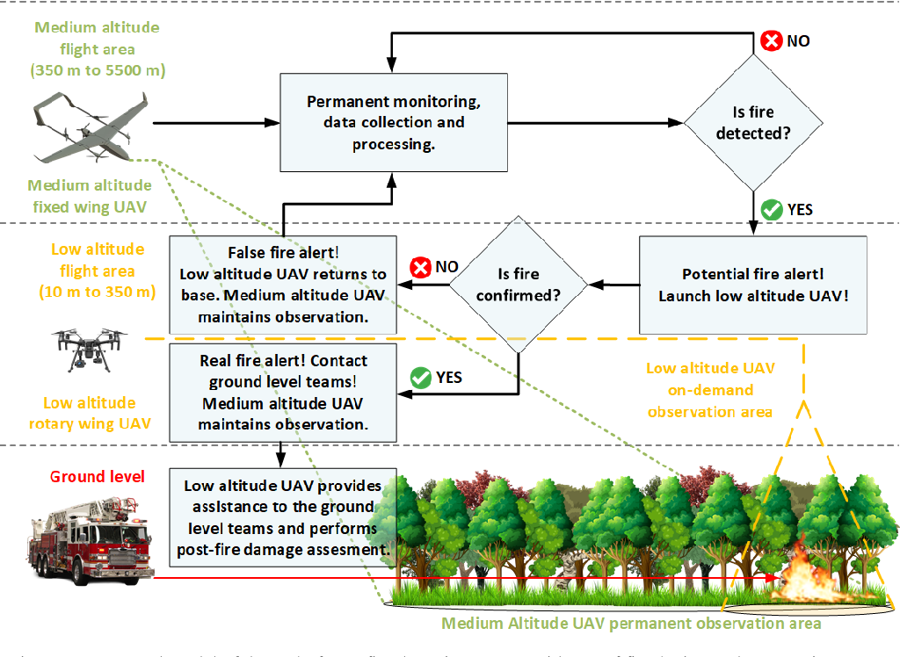

**User Stories :**

| **User Type** | **Functional Requirement (Epic)** | | **User Story Number** | **User Story / Task** | **Acceptance criteria** | **Priority** | **Release** |
| --- | --- | --- | --- | --- | --- | --- | --- |
| Customer (Mobile user) | Registration | | USN-1 | As a user, I can register for the application by entering my email, password, and confirming my password. | I can access my account / dashboard | High | Sprint-1 |
|  |  | | USN-2 | As a user, I will receive confirmation email once I have registered for the application | I can receive confirmation email & click confirm | High | Sprint-1 |
|  |  | | USN-3 | As a user, I can register for the application through Facebook | I can register & access the dashboard with Facebook Login | Low | Sprint-2 |
|  |  | | USN-4 | As a user, I can register for the application through Gmail |  | Medium | Sprint-1 |
|  | Login | | USN-5 | As a user, I can log into the application by entering email & password |  | High | Sprint-1 |
|  | Dashboard | |  |  |  |  |  |
|  |  | |  |  |  |  |  |
| Customer Care Executive | Help & support | | USN-6 | As a customer care, we create a website for answering phones, responding to customer questions and assisting with customer issues | User can login to the website and send their queries | High | Sprint-1 |
| Administrator | Administration | | USN-7 | The administrator can use the tool to provides real-time information on the occurrence of forest fires and also sends SMSs and emails to officials from all forest divisions, subdivisions, and to the members of community forest user’s groups across the country | Administrator can manage the tools that receiving data. | Medium | Sprint-1 |
|  | |